COMPUTER NETWORKS LAB
TASK 4
TCP HEADER INSPECTION
USING WIRESHARK
TCP ports • Sequence and acknowledgement numbers • Header length • Flags • Options • Payload

Name | Kasireddy Srihitha
Roll Number | 2520030153
Section | Sec - 7

1. AIM
To inspect TCP headers in the supplied Wireshark capture file, record the source and destination ports, sequence number, acknowledgement number, TCP header length and payload length for selected packets, and identify TCP connection establishment, termination, options and the packet with the maximum payload.

2. SOFTWARE / INPUT REQUIRED
- Wireshark network protocol analyser.
- Capture file: CN_Lab1.pcapng.
- Display filters used: tcp, tcp.flags.syn == 1, tcp.flags.syn == 1 && tcp.flags.ack == 1, tcp.flags.fin == 1, and tcp.len > 0.

3. PROCEDURE
- Open Wireshark and load the capture file CN_Lab1.pcapng.
- Enter tcp in the Display Filter bar and press Enter to display TCP packets.
- Select TCP packets from the Packet List pane. Expand Transmission Control Protocol in the Packet Details pane.
- Record the source port, destination port, sequence number, acknowledgement number and Header Length for five selected packets. Record TCP Segment Len as the payload length.
- Apply tcp.flags.syn == 1 to display packets with the SYN flag set. Identify SYN packets and SYN-ACK responses. The SYN-ACK filter can be entered as tcp.flags.syn == 1 && tcp.flags.ack == 1.
- Apply tcp.flags.fin == 1 to display packets with the FIN flag set, which are used during TCP connection termination.
- Inspect the Options field under Transmission Control Protocol to identify TCP options such as Maximum Segment Size (MSS), Window Scale and No-Operation (NOP).
- Apply tcp.len > 0 to display packets carrying TCP payload. Sort the TCP Segment Len column in descending order and inspect the first packet to identify the maximum payload length.

4. OBSERVATION TABLE
The following values are transcribed from the Wireshark packet details visible in the screenshots. Sequence and acknowledgement numbers are the relative values displayed by Wireshark.
Packet No. | Source Port | Destination Port | Sequence No. | Acknowledgement No. | TCP Header Length | Payload Length
99 | 443 | 64644 | 1 | 1 | 20 bytes | 120 bytes
524 | 61003 | 443 | 0 | 0 | 32 bytes | 0 bytes
611 | 60777 | 443 | 0 | 0 | 32 bytes | 0 bytes
28254 | 57395 | 443 | 1 | 1 | 20 bytes | 0 bytes
2420 | 443 | 57125 | 121 | 347 | 20 bytes | 120 bytes
Note: Packet 611 is visible in the SYN-filtered packet list with source port 60777 and destination port 443; the displayed SYN details show sequence number 0, acknowledgement number 0 and no payload. TCP Segment Len represents the TCP payload length.

5. TCP CONNECTION ESTABLISHMENT
The SYN filter displays TCP packets with the SYN bit set. A client SYN packet has SYN = 1 and ACK = 0. A server SYN-ACK response has SYN = 1 and ACK = 1. These packets are part of the TCP three-way handshake used to establish a connection.
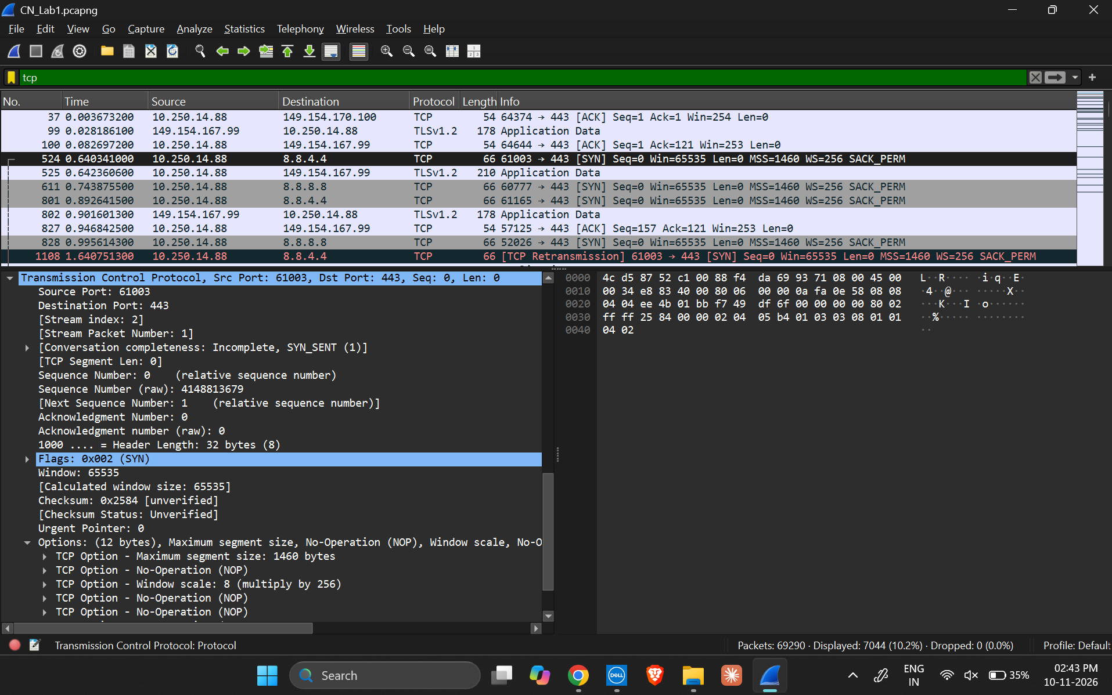
SCREENSHOT 1: TCP PACKETS AND SYN HEADER DETAILS WITH TCP OPTIONS

6. TCP CONNECTION TERMINATION
The filter tcp.flags.fin == 1 displays packets with the FIN flag set. The selected packet No. 28254 has source port 57395, destination port 443, sequence number 1, acknowledgement number 1, a 20-byte TCP header and 0-byte payload. FIN is used to indicate that a sender has finished sending data.
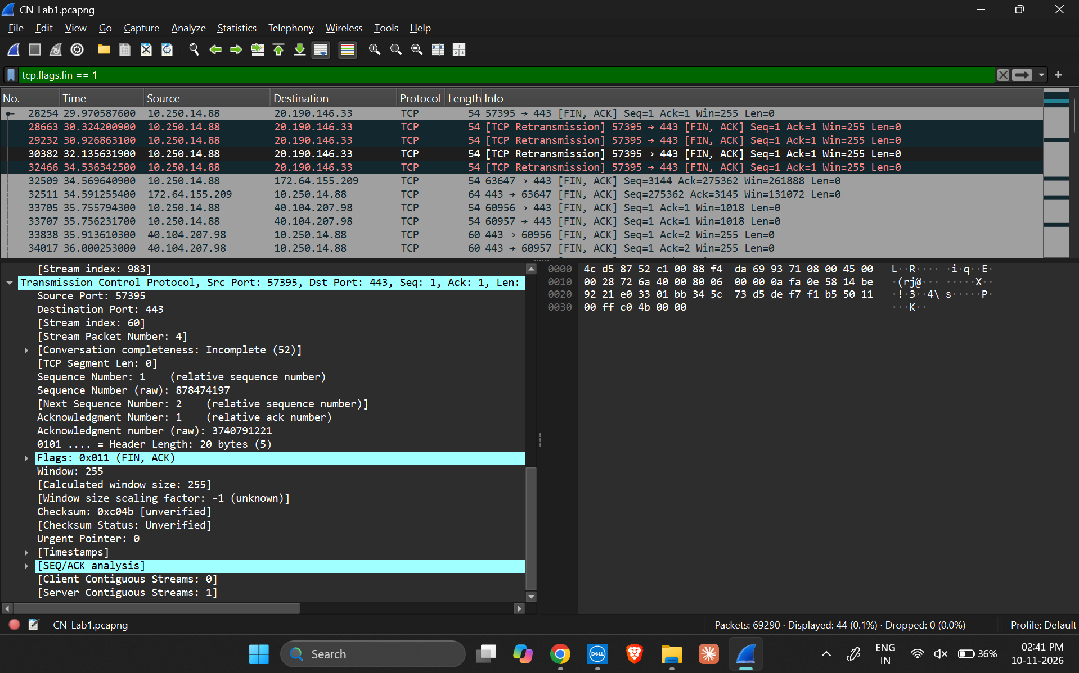
SCREENSHOT 2: FIN-FLAGGED PACKETS AND SELECTED TCP HEADER

7. TCP OPTIONS IDENTIFIED
The expanded TCP Options field in the selected SYN packet shows a Maximum Segment Size of 1460 bytes, Window Scale of 8 (multiply by 256), and No-Operation (NOP) padding entries. These options provide additional information used during TCP communication.

8. MAXIMUM TCP PAYLOAD
The display filter tcp.len > 0 was used to show TCP packets with payload. The TCP Segment Len column was sorted in descending order. The largest observed TCP payload length is 120 bytes. Packet No. 2420 was selected for verification: source port 443, destination port 57125, sequence number 121, acknowledgement number 347, TCP header length 20 bytes and payload length 120 bytes.
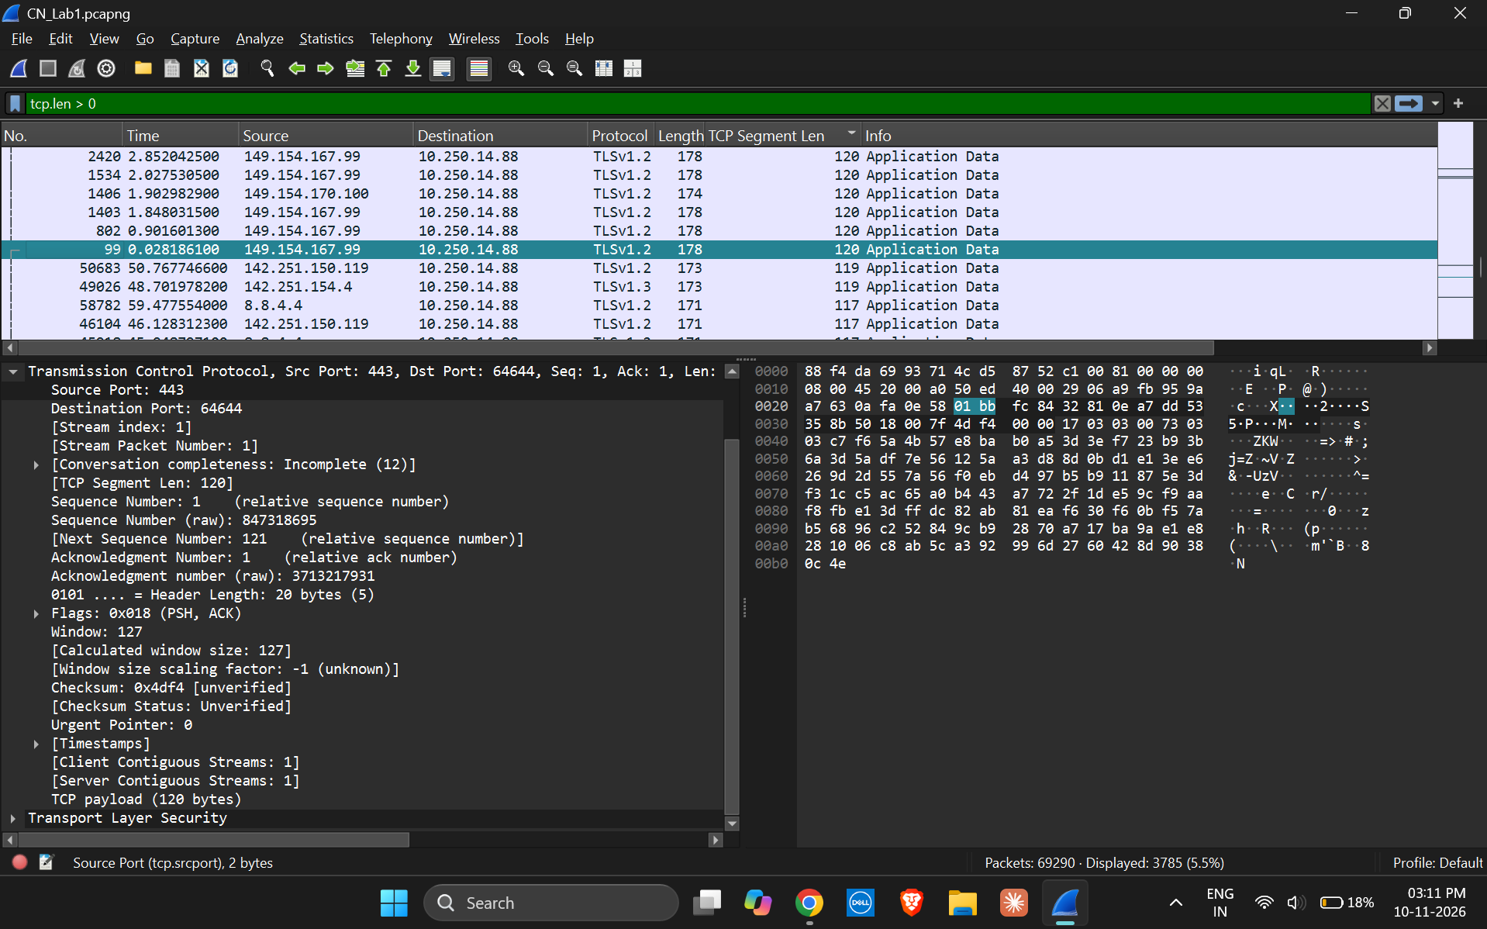
SCREENSHOT 3: TCP PAYLOAD PACKETS SORTED BY TCP SEGMENT LENGTH
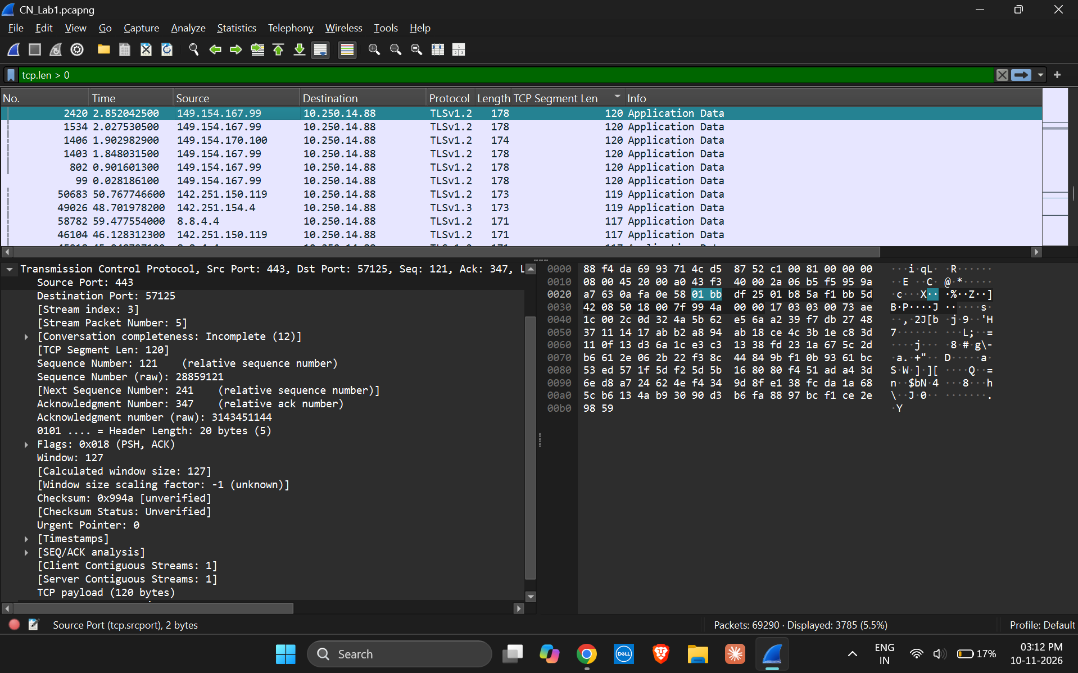
SCREENSHOT 4: PACKET 2420 SHOWING THE MAXIMUM TCP PAYLOAD OF 120 BYTES

9. SUPPORTING TCP PAYLOAD INSPECTION
Packet No. 99 is another TCP payload-bearing packet visible in the capture. Its source port is 443, destination port is 64644, sequence number is 1, acknowledgement number is 1, TCP header length is 20 bytes and payload length is 120 bytes.
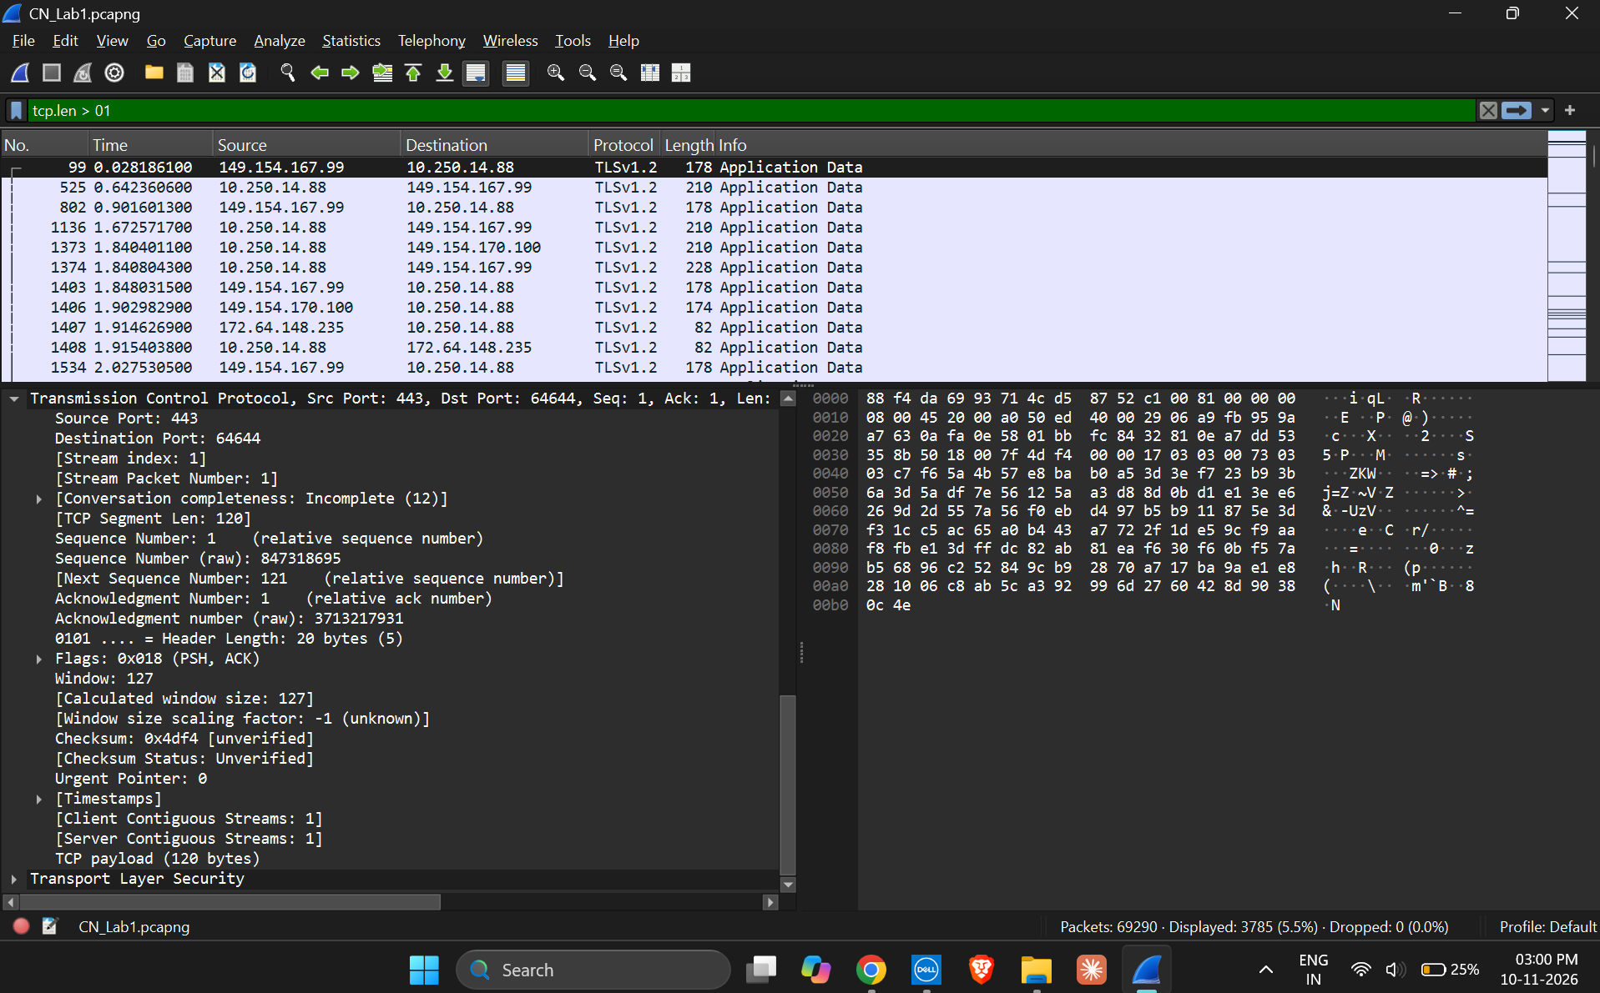
SCREENSHOT 5: TCP PACKET DETAILS SHOWING TCP SEGMENT LENGTH OF 120 BYTES

10. RESULT
TCP headers were inspected in Wireshark and the required fields were recorded for five selected packets. SYN and SYN-ACK packets used for connection establishment, FIN packets used for connection termination, and TCP options including MSS, Window Scale and NOP were identified. The maximum TCP payload observed in the inspected packets was 120 bytes.

11. CONCLUSION
The activity demonstrated how Wireshark can be used to examine TCP header fields and control flags. The inspection showed how TCP uses sequence and acknowledgement numbers, header options and SYN/FIN flags to support reliable connection-oriented communication. Filtering and sorting by TCP payload length also made it possible to identify the largest payload observed in the capture.

12. FINAL SUBMISSION CHECKLIST
- Fill in the student name, roll number, section and date on the cover page.
- Check that all five screenshots are visible and readable in the document.
- Verify that the observation values match the Wireshark packet details.
- Save the completed report as a .docx file.
- Keep the original CN_Lab1.pcapng capture file if the instructor requires it.

